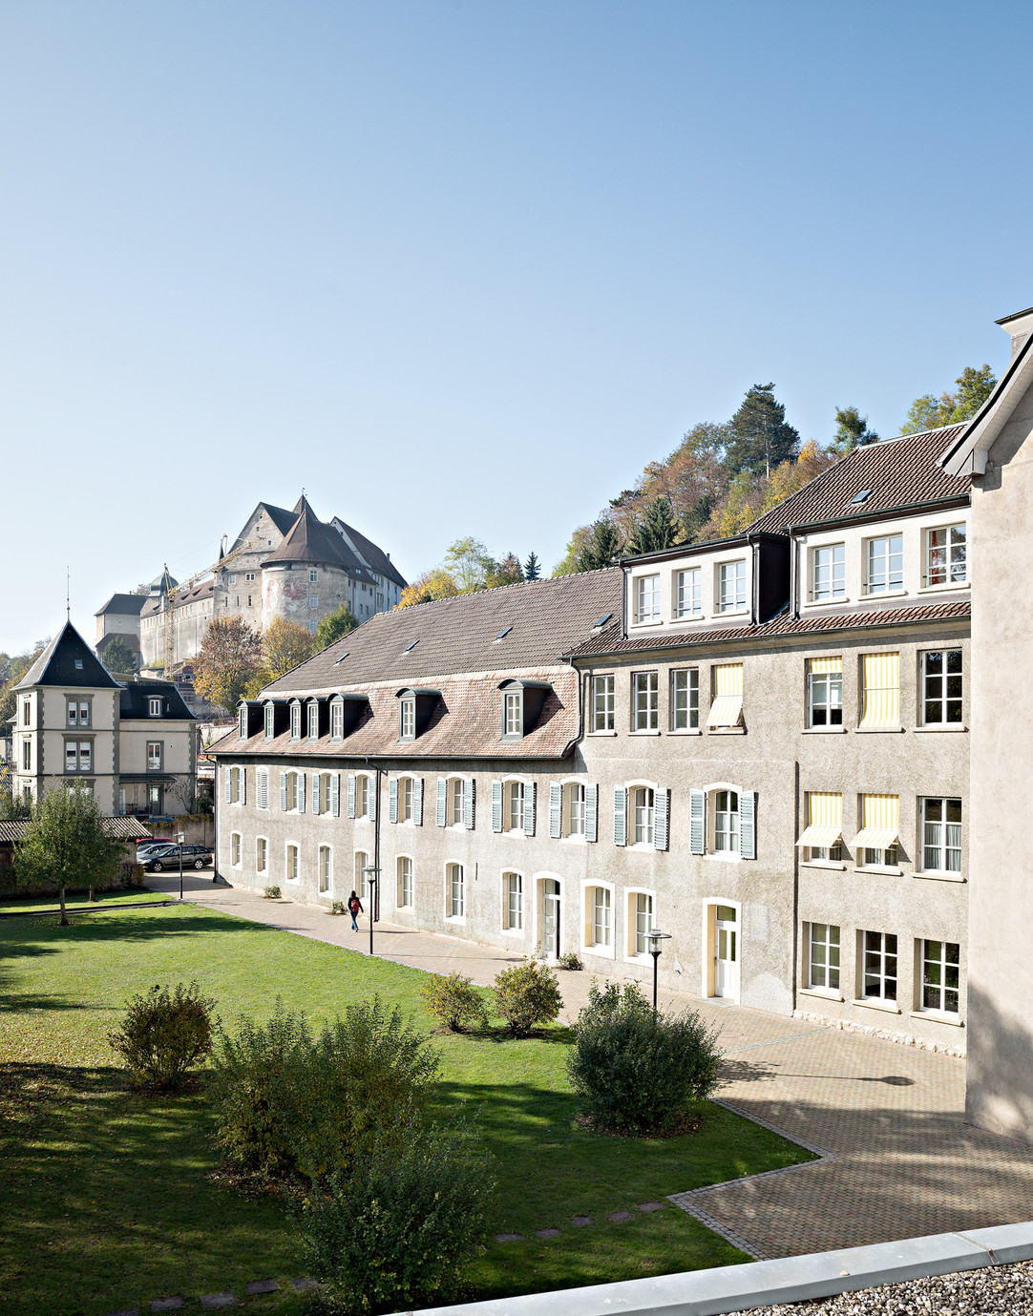
Application form
Day school

Rte de Belfort 10 | CP 1156 | CH-2900 Porrentruy | +41 32 466 11 57
secretariat@saint-charles.ch | www.saint-charles.ch

Passport-sized photo

Rte de Belfort 10 | CP 1156 | CH-2900 Porrentruy | +41 32 466 11 57
secretariat@saint-charles.ch | www.saint-charles.ch
- Student

Last name | First name
Gender F M | Date of birth (dd/mm/yyyy)
Main Nationality | Place of origin
Mother tongue | Other spoken languages
Mobile phone | E-mail
Religion | Social security number (Swiss citizens : AVS)
Health insurance | Insurance number
Liability Insurance
Transit pass : oui non
If yes : Half-fare Abonnement Général (AG) VagABOnd (specify area) : Other (specify) :
How many Borthers and sisters in Collège et Lycée Saint-Charles :

- Academic information

Current school | Current year at the moment
Current grade | Grade repeated yes no
Details of the main teacher or Director of the actual school

Starting date desired | Grade desired

- Family information

Parent 1 :  Mr Ms. Last name | father mother other (specify)  Frist name
Adress
Place and code
Country | Language for correspondence
E-mail | Mobile phone
Private phone | Business phone
Profession | Employer
Marital status Married Separated Divorced Single Widower
Member of Alumni Yes No
Parent 2 :  Mr Ms. Last name | father mother other (specify)  Frist name
Adress
Place and code
Country | Language for correspondence
E-mail | Mobile phone
Private phone | Business phone
Profession | Employer
Marital status Married Separated Divorced Single Widower
Member of Alumni Yes No

Only to be completed if different from parent 1 and 2
Legal guardian : father mother other (specify)
Mr. Mrs Last name | First name
Adress
Place and code
Country | Language for correspondence
E-mail | Mobile phone
Private phone | Business phone
Profession | Employer
Marital status Married Separated Divorced Single Widower
Member of Alumni Yes No

- Parental authority

 | Parent 1 | Parent 2 | Both parents | Other
If parents are divorced or separated, who has legal custody of the child ?
(in case of unique legal authority, please attach a copy of the judgment)
If parents are divorced or separated, with whom does the student live ?
If parents are divorced or separated, where should the invoices be sent ? (only one choice possible)

- Personal information

Has the student ever received any type of specialised support ? (if yes, please specify) oui non
Speech therapy Psychomotor Child psychiatry Psychology Other

Has the student ever experienced difficulties in any of the following areas ?
Allergies Hyperactivity Other(s) On-going treatment Useful information

- Information in cases of emergency

Contact person | Mobile phone
Private phone | Business phone

Family doctor | Phone number
In a case of emergency, I authorize School personnal to transport my child to a doctor or to the hospital depending of the situation yes no

- General information

How did you hear about Collège et Lycée Saint-Charles ?
Current/parent or Former student/parent | Family/friends
Website | Events
Advertising | Other
Educational agent (specify)

- Payment method

Annual Half-year ( Monthly )

- Particular remarks

- Signature of parents or legal guardian
By signing this document, the parents, and/or representative legally and/or financially responsible, confirm that they have read, understood and accepted the general terms and financial conditions here attached. Parents, and/or legal guardian hereby declare that all the enclosed information is correct.

Date Parent 1 signature

Date Parent 2 signature

Only to be filled if necessary
Date Legal guardian’s signature

Registration is considered definite upon reception of the admission fees (see general terms).

As specified in the Terms and financial conditions, all personnal data is collected by Collège et Lycée Saint-Charles.
I agree
Parents must accept the terms regarding data protection in order to validate the registration.
I agree (MANDATORY)

- Collège et Lycée Saint-Charles Foundation (provides scholarships for students)

I would like to make a donation to the Collège et Lycée Saint-Charles Foundation
I do not want to make a donation to the Collège et Lycée Saint-Charles Foundation

- Photo / Data protection

I agree that my child’s photograph may be used in school communication
I do not agree that my child’s photograph may be used in school communication

- Required documents

Recent passport-sized photo | Confidential questionnaire | Photocopy of the passport, identity card or residence permit | School reports from the last two years | Report and decisions of granted compensation measures (cf. point 5)

DAY SCHOOL GENERAL CONDITIONS 2018-2019

Introduction
The present General Conditions shall govern all contractual aspects of the relationships between the parents of our students and the Collège & Lycée Saint-Charles. They shall cover methods of communication, privacy policies and admission conditions as applicable in the Jura region and the rest of Switzerland. The school’s various regulations, such as the General Conditions and the boarding school regulations, are available on the website and during the enrolment interview.

- Admission
For admittance to the Collège & Lycée Saint-Charles, a form must be completed and submitted to the Collège’s administration.
An interview with the admissions committee is required and the final registration shall be validated by payment of the admission fee. Sibling discounts do not apply to admission fees
A one-time admission fee of CHF 500 will be payable for each new student. This will not be refundable if the admission is cancelled. Any other indemnities for breach of contract are expressly reserved.

ADMISSION FEE | CHF 500

- Tuition, boarding and general costs
The tuition and boarding fees are detailed below. They include all lessons according to the syllabus, homework supervision and allowances, as detailed below. The tuition fees include fees for all courses shown in the class schedule, as well as supervised homework.
The official language for educational purposes is French. English is taught at all levels of the school and is also a teaching language in the bilingual Lycée. The official languages of the school are French, English, German and Italian at the Lycée.
Other languages not included in the official curriculum may be taught as extra-curricular activities. Rates for group lessons apply when 4 or more students attend; if there are fewer than 3 participants, the class will be billed as a semi-private or private lesson.

TUITION FEES
 | JURA | OUTSIDE THE CANTON
PRIMARY SCHOOL COURSE SWITZERLAND | CHF 6,600 | CHF 14,400
SECONDARY SCHOOL COURSE SWITZERLAND (COLLÈGE) | CHF 7,200 | CHF 18,000
SWISS LYCÉE - MATURITÉ (FRENCH) | CHF 9,600 | CHF 20,400
BILINGUAL LYCÉE ENGLISH-FRENCH - MATURITÉ SWITZERLAND | CHF 12,000 | CHF 24,000
INTERNATIONAL SECTION (IB) | CHF 30,000 | CHF 30,000

Boarding fees
The boarding fees include lunch.

ANNUAL BOARDING FEES
1 LUNCH PER WEEK | CHF 390.-
2 LUNCHES PER WEEK | CHF 780.-
3 LUNCHES PER WEEK | CHF 1.170.-
4 LUNCHES PER WEEK | CHF 1.560.-
5 LUNCHES PER WEEK | CHF 1.950.-

General fees
General fees for books, school supplies, outings, special activity weeks (ski camp, primary-level field trips, other trips and inter-disciplinary weeks), cultural and sports activities and general administrative costs are billed per semester, once before the beginning of the school year, in July; and again before the start of the second semester, in January. The total will vary depending on the choice of school programme and year.
A snack break taken between the last lesson slot and the supervised homework period is included in the general fee.

GENERAL FEES
 | JURA | OUTSIDE THE CANTON
PRIMARY SCHOOL | CHF 1,000 | CHF 1,000
SECONDARY SCHOOL COURSE SWITZERLAND (COLLÈGE) | CHF 1,500 | CHF 1,500
SWISS LYCÉE - MATURITÉ (FRENCH) | CHF 1,500 | CHF 1,500
BILINGUAL LYCÉE ENGLISH-FRENCH - MATURITÉ SWITZERLAND | CHF 1,500 | CHF 1,500
INTERNATIONAL SECTION (IB) | CHF 2,500 | CHF 2,500

- Support and coaching classes in individual classes or in small groups
Support and coaching classes for small groups will be charged at the rate described below. Any additional private, semi-private or group classes are billed separately.

PRIVATE, SEMI-PRIVATE AND GROUP CLASSES - INDIVIDUAL SUPPORT AND COACHING

PRIVATE CLASSES (LENGTH: 45 MINUTES) | CHF 100
SEMI-PRIVATE CLASSES, MAX. 3 STUDENTS (LENGTH: 45 MINUTES) | CHF 60
GROUP CLASSES (FOUR STUDENTS OR MORE, LENGTH: 45 MINUTES) | CHF 30

- Preparation courses for language exams and examination fees
Any fees for preparation courses for official language diplomas will be invoiced during the semester. Additional fees are applied for the final ECS (Écoles Catholiques Suisses - Swiss Catholic Schools) examination.
Additional fees also apply for official examinations such as Cambridge, Goethe, CELI etc., as well as additional group lessons outside the normal timetable.
All students sitting the Maturité exam will be charged the examination fee according to the canton’s official price list. These fees are included in the general fee.

OTHER ACADEMIC SERVICES
PREPARATION COURSES FOR LANGUAGE EXAMS BY SEMESTER | CHF 1000
EXAMINATION FEES
ECS EXAMS (SWISS CATHOLIC SCHOOLS) | CHF 60
MATURITÉ EXAMS (PRICE LIST REGULATED BY THE CANTON, SUBJECT TO LEGAL AMENDMENTS) | CHF 100
LANGUAGE EXAMINATION FEES | CHF 400
INTERNATIONAL BACCALAUREATE EXAMS (MYP) | CHF 2,980

- Textbooks and school supplies
Textbooks will be loaned to the students during compulsory schooling but need to be purchased at Lycée level. Books, exercise books, basic school supplies and support materials for extra classes are included in the general fee. Any licenses required for the use of digital textbooks will be charged separately.
- IT equipment
Any student may at any time use PCs or Mac computers compatible with Office 365, provided by the school. Wireless network connections are available at the school. The school provides complete suites of computer equipment, both in the classrooms and in those rooms devoted to teaching computer science. If IT material is loaned to a student, it shall become that student’s responsibility. In the event of any damage, theft or loss affecting that equipment, the appropriate fees will be charged.
- Activities
All costs related to cultural or extracurricular activities are included in the general fee.
- Communication
For environmental reasons, the Collège & Lycée Saint-Charles encourages the use of electronic communication methods. By signing these General Conditions, you consent to automatically receive all correspondence by email. If you do not wish this to happen, please put your email address in parentheses on the registration form.
- Agreement for the use of photos for school marketing and documentation purposes.
For promotional and marketing reasons, the Collège & Lycée Saint-Charles produces and distributes promotional material on a regular basis. School events are highlighted on our Facebook page and on other social networks. If you do not wish for your child to appear in such publications, please state this expressly on the registration form.
Privacy Policy
The College & Lycée Saint-Charles complies with Swiss legislation with regard to the protection of personal information. Any person may, at any time, access, modify, or delete their personal information, especially after leaving the school.
Any personal data collected by the Collège & Lycée Saint-Charles at the time of enrolment will be used for admission purposes, administrative management of the studies and, if needed, internships within Collège & Lycée Saint-Charles, as well as to provide other services to students.
The Collège & Lycée Saint-Charles may, under certain conditions, forward personal information to contractors within the school to whom it subcontracts services (such as cooks, travel partners, and out-of-school camp organisers).
- Invoicing
Billing for tuition fees and boarding is processed annually, with 12 payment slips. All invoices are payable in advance, before the start of the classes. Billing may be processed by semester, on request. Any additional, non-included fees will be charged separately twice a year. Payments in cash will not be accepted.
In the event of a new arrival or a switch during the year, tuition will be charged pro-rata from the first day of the month.
- Payment terms
All invoices must be paid within 30 days of issue; the currency to be used is the Swiss Franc (CHF).
After this deadline, late payment interest will be charged at 1% per month. Administrative and reminder fees are charged in the event of late payment:
- 1st reminder: CHF 20
- 2nd reminder: CHF 50
- 3rd reminder: CHF 100
No place reservation can be processed until the registration fee has been paid. Any complaints concerning an invoice must be sent to the Collège via post within 30 days of its issue.
Students may not attend any class until all invoices have been paid.

- Cancellation, change of status, notification, dismissal and related fees
For new students:
If registration is cancelled before 30 June, cancellation fees equivalent to two months of tuition will be charged.
A cancellation fee equivalent to three months of schooling will be applied if the registration is cancelled after 30 June.
For current students:
In the event that parents decide to withdraw a student before the end of the school year, all expenses for the current quarter shall be payable.
Any internal student transferring to the boarding school shall be subject to the same conditions.
Unless written notice is given by parents before 31 March, students are automatically entered for the following school year. If the automatic inscription is cancelled after 31 March, the tuition fees for the first three months will be payable as compensation.
In the event of a student being dismissed, all fees for the current quarter shall be payable.
- Student absence
As of the fourth consecutive week of any legitimate absence, half-board shall no longer be charged. A reduction will be granted to boarding school pupils.
No further reductions shall apply to tuition or other taxes.
- Family reductions
Children from the same family benefit from the following reductions:
- Second child: 10% off tuition fees and board;
- Third child: 15% off tuition fees and board.
There shall be no discount on any other billed items.
- Canton of Jura bursaries for Lycée students
Lycée students whose home address is in the Canton can benefit from state bursaries, pursuant the applicable laws regulating formal schools. At the beginning of the school year, the necessary information and forms are issued by the classroom teachers.
- Canton of Jura bursaries for students of the obligatory school
Our students can apply for scholarships for the obligatory school. Relevant information on this topic will be sent to you by the beginning of the school year.
- Financial contributions provided by Jura municipalities
Many municipalities pay part of the school fees they would be required to pay to public secondary schools either to the parents or directly to the Collège & Lycée Saint-Charles. The administration department of Collège & Lycée Saint-Charles or of your local authority can provide further information.

- Code of conduct and school regulations (dress code, drugs, alcohol, interpersonal respect)
The school codes of conduct and regulations are available on the website and form an integral part of these General Conditions. Failure to respect these codes will lead to disciplinary action. In the event of a serious violation of this contract or the current codes of conduct, the student may be dismissed with immediate effect.
By signing, parents accept that the school may test their child for the consumption of alcohol or non-prescription drugs. Parents hereby acknowledge that any student who supplies, possesses, or tests positive for non-prescription medications or drugs will be required to leave the school.
- Personal belongings
The school strongly discourages students from bringing high-value items such as designer clothing, watches, or jewellery onto the premises. The management shall accept no responsibility for unmarked items and / or valuables that are not deposited with the boarding school prefects.
- Changes to financial conditions
Upon their acceptance, these financial conditions apply to all students admitted for the current school year, irrespective of whichever edition of the financial conditions may have initially been signed by the parents. This edition of the financial conditions shall apply to all parents automatically. They can be sent to them on request by the administration department.
- Applicable law and place of jurisdiction
Only Swiss law is applicable to the relationships resulting from this contract, regardless of the home address of the parents or legal representatives. Any legal conflict which could arise from this contract will be submitted to the jurisdiction of the Canton of Jura and the district of Ajoie in Porrentruy.

By signing this contract, the parents or legal guardians of the student undertake to fully accept the general conditions, school regulations and codes of conduct, and in case of re-registration, the general conditions that will be adapted for the following years, as well as any clauses forming part of the regulations of the College & Lycée Saint-Charles.

Parent 1
Name and surname: ………………………………………………………………………………………………
Date and place: ………………………………………………………………………………………………….….
Signature: …………………………………………………………………………………………………………

Parent 2
Name and surname: ………………………………………………………………………………………………
Date and place: ……………………………………………………………………………………………………..
Signature: …………………………………………………………………………………………………….…..

Legal representative
Name and surname: ………………………………………………………………………………………………..
Date and place: ……………………………………………………………………………………………………
Signature: ……………………………………………………………………………………………………………

