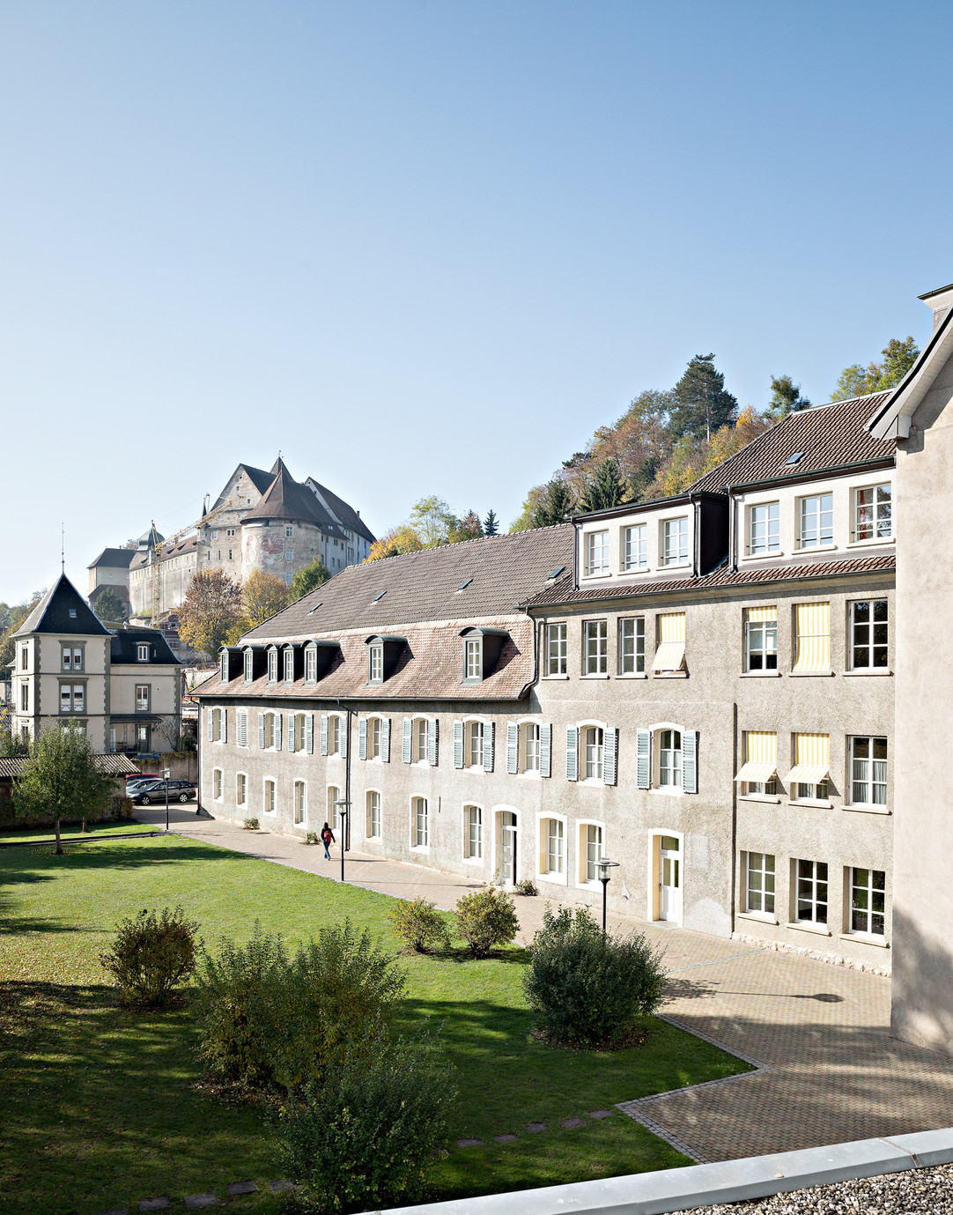
Application form
Boarding school

Rte de Belfort 10 | CP 1156 | CH-2900 Porrentruy | +41 32 466 11 57
secretariat@saint-charles.ch | www.saint-charles.ch

Passport-sized photo

Rte de Belfort 10 | CP 1156 | CH-2900 Porrentruy | +41 32 466 11 57
secretariat@saint-charles.ch | www.saint-charles.ch
- Student

Last name | First name
Gender F M | Date of birth (dd/mm/yyyy)
Main Nationality | Place of origin
Mother tongue | Other spoken languages
Mobile phone | E-mail
Religion | Social security number (Swiss citizens : AVS)
Health insurance | Insurance number
Liability Insurance
Transit pass : oui non
If yes : Half-fare Abonnement Général (AG) VagABOnd (specify area) : Other (specify) :
How many Borthers and sisters in Collège et Lycée Saint-Charles :

- Academic information

Current school | Current year at the moment
Current grade | Grade repeated yes no
Details of the main teacher or Director of the actual school

Starting date desired | Grade desired

Boarding school 5 days | Boarding school 7 days

- Family information

Parent 1 :  Mr Ms. Last name | father mother other (specify)  Frist name
Adress
Place and code
Country | Language for correspondence
E-mail | Mobile phone
Private phone | Business phone
Profession | Employer
Marital status Married Separated Divorced Single Widower
Member of Alumni Yes No
Parent 2 :  Mr Ms. Last name | father mother other (specify)  Frist name
Adress
Place and code
Country | Language for correspondence
E-mail | Mobile phone
Private phone | Business phone
Profession | Employer
Marital status Married Separated Divorced Single Widower
Member of Alumni Yes No

Only to be completed if different from parent 1 and 2
Legal guardian : father mother other (specify)
Mr. Mrs Last name | First name
Adress
Place and code
Country | Language for correspondence
E-mail | Mobile phone
Private phone | Business phone
Profession | Employer
Marital status Married Separated Divorced Single Widower
Member of Alumni Yes No

- Parental authority

 | Parent 1 | Parent 2 | Both parents | Other
If parents are divorced or separated, who has legal custody of the child ?
(in case of unique legal authority, please attach a copy of the judgment)
If parents are divorced or separated, with whom does the student live ?
If parents are divorced or separated, where should the invoices be sent ? (only one choice possible)

- Personal information

Has the student ever received any type of specialised support ? (if yes, please specify) oui non
Speech therapy Psychomotor Child psychiatry Psychology Other

Has the student ever experienced difficulties in any of the following areas ?
Allergies Hyperactivity Other(s) On-going treatment Useful information

- Information in cases of emergency

Contact person | Mobile phone
Private phone | Business phone

Family doctor | Phone number
In a case of emergency, I authorize School personnal to transport my child to a doctor or to the hospital depending of the situation yes no

- General information

How did you hear about Collège et Lycée Saint-Charles ?
Current/parent or Former student/parent | Family/friends
Website | Events
Advertising | Other
Educational agent (specify)

- Payment method

Annual Half-year ( Monthly )

- Particular remarks

- Signature of parents or legal guardian
By signing this document, the parents, and/or representative legally and/or financially responsible, confirm that they have read, understood and accepted the general terms and financial conditions here attached. Parents, and/or legal guardian hereby declare that all the enclosed information is correct.

Date Parent 1 signature

Date Parent 2 signature

Only to be filled if necessary
Date Legal guardian’s signature

Registration is considered definite upon reception of the admission fees (see general terms).

As specified in the Terms and financial conditions, all personnal data is collected by Collège et Lycée Saint-Charles.
I agree
Parents must accept the terms regarding data protection in order to validate the registration.
I agree (MANDATORY)

- Collège et Lycée Saint-Charles Foundation (provides scholarships for students)

I would like to make a donation to the Collège et Lycée Saint-Charles Foundation
I do not want to make a donation to the Collège et Lycée Saint-Charles Foundation

- Photo / Data protection

I agree that my child’s photograph may be used in school communication
I do not agree that my child’s photograph may be used in school communication

- Required documents

Recent passport-sized photo | Confidential questionnaire | Photocopy of the passport, identity card or residence permit | School reports from the last two years | Report and decisions of granted compensation measures (cf. point 5)

BOARDING SCHOOL GENERAL CONDITIONS 2018-2019

Introduction
The present General Conditions shall govern all contractual aspects of the relationships between the parents of our students and the Collège & Lycée Saint-Charles. They shall cover methods of communication, privacy policies and admission conditions as applicable to all boarding school students, whether originating from the Jura region, elsewhere in Switzerland, elsewhere in the EU or outside the EU. The school’s various regulations, such as general conditions, boarding school regulations and the dress code, are available on the website and during the enrolment interview.

- Admission
For admittance to the Collège & Lycée Saint-Charles, a form must be completed and submitted to the Collège’s administration.
An interview with the admissions committee is required and the final registration shall be validated by payment of the admission fee. Sibling discounts do not apply to admission fees.
The admission fee is CHF 3,000. It covers the administrative costs for the admission process and is non-refundable. Any other indemnities for breach of contract are expressly reserved.
Students are admitted to the boarding school of the Collège & Lycée Saint-Charles from age 10. A student enrolled at Collège & Lycée Saint-Charles will not be allowed to live alone.
ADMISSION FEE | CHF 3,000

- Swiss visas and residence permits
Students may only attend courses if they have the necessary permits and visas. On an administrative level, the College & Lycée Saint-Charles will handle residence permits for all students, based on the documents provided by their legal representatives. The residence permit will be recognised in all countries within the Schengen area.
However, we do ask that parents submit a student visa application (for non-European students only) upon receipt of documents from the College & Lycée Saint-Charles. The latter shall accept no responsibility for late arrivals due to any issues with visas or any other documents necessary for the student's entry into Switzerland. In such cases, the expenses for the first quarter shall still be payable.
Each non-European student must be registered with the originating country’s embassy in Switzerland by their parents.

- Tuition and boarding fees
The tuition and boarding fees are detailed below. They include all lessons according to the syllabus, homework supervision and allowances, as detailed below.
TUITION FEES
PRIMARY SCHOOL COURSE SWITZERLAND | CHF 14,400
SECONDARY SCHOOL COURSE SWITZERLAND (COLLÈGE) | CHF 19,500
SWISS LYCÉE - MATURITÉ (FRENCH) | CHF 21,900
BILINGUAL LYCÉE ENGLISH-FRENCH - MATURITÉ SWITZERLAND | CHF 24,000
INTERNATIONAL SECTION (IB) | CHF 30,000

Boarding school fees
The 5-day boarding school services are described in detail below.
5-DAY BOARDING SCHOOL
CHF 32,700
INCLUDED | NOT INCLUDED
Boarding school programme  Full board  Residence permit fees  Books and school supplies  Animation programme  Supervised homework  Sports outfit (t-shirts, leggings or jogging pants)  On-premises and local extracurricular activities (curling, swimming, martial arts, archery, athletics, football)  Day trips  Outings, concerts and theatre visits  Ski or sports camps (graduation trip not included)  Ski or sports camps (graduation trip not included) | LAMAL and private health insurance, dentist fees  Books and additional supplies (in case of loss or damage). Digital handbook licenses  Academic coaching (group of 4 students or more), private lessons, additional FLE/AEL courses  Preparation courses for language exams (CAMBRIDGE, GOETHE, TFSA, CERVANTES), examination fees  Horse riding, music lessons, golf, aviation, etc.  Travelling  Pocket money  Airport transfers  Ski equipment rentals  Laundry and dry-cleaning  Occasional weekends at the boarding school

The 7-day boarding school services are described in detail below.
7-DAY BOARDING SCHOOL
CHF 47,000
INCLUDED | NOT INCLUDED
Boarding school programme including weekend activities  Full board  Residence permit fees  Books and school supplies  Animation programme  Supervised homework  Sports outfit (t-shirts, leggings or jogging pants)  On-premises and local extracurricular activities (curling, swimming, martial arts, archery, athletics, football)  Day trips  Outings, concerts and theatre visits  Ski or sports camps (graduation trip not included)  Four long weekends in the mountains or in a city  Laundry | LAMAL and private health insurance, dentist fees  Books and additional supplies (in case of loss or damage), digital handbook licenses  Academic coaching (group of 4 students or more), private lessons, additional FLE/AEL courses  Preparation courses for language exams (CAMBRIDGE, GOETHE, TFSA, CERVANTES)  Examination fees  Horse riding, music lessons, golf, aviation, etc.  Travelling  Pocket money  Airport transfers  Ski equipment rentals  Laundry: extra cleaning and dry-cleaning
VAT is added wherever applicable.
- Academic services subject to separate fees
The official language for educational purposes is French. English is taught at all levels of the school and is also a teaching language in the bilingual Lycée and in the international section. The official languages of the school are French, English, German, Italian, and Spanish at the Lycée. Other languages not included in the official curriculum may be taught as extra-curricular activities. Rates for group lessons apply when 4 or more students attend; if there 3 or fewer participants, the class will not take place or will be billed as a semi-private or private lesson.
Additional FLE (French as a Foreign Language) and AEL (English as an Additional Language) courses are charged separately. Classes take place for groups of at least 4 students; if there are fewer than 4 participants, the class will be billed as a semi-private or private lesson. FLE/AEL classes may be made obligatory if the minimum level required for the syllabus is not met. The student's parents will be informed in any event.
ADDITIONAL FLE/AEL CLASSES - ANNUAL FEE
A maximum of 8 periods per week or pro-rata billing | CHF 8,880

Support and coaching classes in individual classes or in small groups
Support and coaching classes in small groups will be charged at the rate described below. Any additional private, semi-private or group classes are billed separately.

PRIVATE, SEMI-PRIVATE AND GROUP CLASSES - INDIVIDUAL SUPPORT AND COACHING
PRIVATE CLASSES (LENGTH: 45 MINUTES) | CHF 100
SEMI-PRIVATE CLASSES, MAX. 3 STUDENTS (LENGTH: 45 MINUTES) | CHF 60
GROUP CLASSES (FOUR STUDENTS OR MORE, LENGTH: 45 MINUTES) | CHF 30

Preparation courses for language exams and examination fees
Any fees for preparation courses for official language diplomas will be invoiced during the semester. Additional fees are applied for the final ECS (Official Swiss Catholic Schools) examination.
Additional fees also apply for official examinations such as Cambridge, Goethe, CELI etc., as well as additional group lessons outside the normal timetable.
All students sitting the Maturité exam will be charged the examination fee according to the canton’s official price list.

OTHER ACADEMIC SERVICES
PREPARATION COURSES FOR LANGUAGE EXAMS BY SEMESTER | CHF 1,000
EXAMINATION FEES
ECS EXAMS (SWISS CATHOLIC SCHOOLS) | CHF 60
MATURITÉ EXAMS (PRICE LIST REGULATED BY THE CANTON, SUBJECT TO LEGAL AMENDMENTS) | CHF 100
LANGUAGE EXAMINATION FEES | CHF 400
INTERNATIONAL BACCALAUREATE EXAMS (MYP) | CHF 2,980

- Books and school supplies
Textbooks are available for loan during compulsory schooling but need to be purchased at Lycée level or for the international section. Books, exercise books and basic school supplies are included in the internship fees. Any licenses required for the use of digital textbooks will be invoiced separately. There will be a charge for replacements for lost or damaged books and school supplies.
- Cultural and academic activities
The boarding school fees cover conferences and cultural outings such as: theatre visits, concerts and academic excursions. Travel abroad may form an integral part of the academic curriculum and additional fees will be applied. Parents will be notified of these fees in advance on the corresponding registration form. Registration for these activities is final and non-refundable.

- Sports and entertainment
The boarding fees also cover sports activities and entertainment, including school-related sports activities, local sports clubs, admission to local sports facilities (except for gym memberships) and weekend activities according to the list provided at the beginning of the school year.
- IT equipment
Any student may at any time use PCs or Mac computers compatible with Office 365, provided by the school. Wireless network connections are available at the school. The school provides complete suites of computer equipment, both in the classrooms and in those rooms devoted to teaching computer science. If IT material is loaned to a student, it shall become that student’s responsibility. In the event of any damage, theft or loss affecting that equipment, the appropriate fees will be charged.
- Insurance
Health and accident insurance: These are compulsory in Switzerland for all students. The Collège & Lycée Saint-Charles organises insurance and bills parents for the expenses. Students who have an insurance certificate issued by a company based in Switzerland and offering the necessary guarantees shall present it at the time of registration. Their insurance card must be presented on arrival at the Collège.
Since insurance rates are annual and depend on the decisions of the relevant federal authorities, an estimate of the costs is charged before the beginning of the school year and a settlement is subsequently established.
Students will be charged for medical and nursing costs.
HEALTH AND ACCIDENT INSURANCE COSTS
BASIC SWISS FEDERAL LAW AND PRIVATE HEALTH INSURANCE | CHF 2300

- Other fees
Any other fees not mentioned in these Terms and Conditions will be subject to separate criteria and billing.
- Family reductions
Children from the same family benefit from the following reductions:
- Second child: 10% off tuition fees and board;
- Third child: 15% off tuition fees and board.
There shall be no discount on any other billed items.
- Communication
For environmental reasons, the Collège & Lycée Saint-Charles encourages the use of electronic communication methods. By signing these General Conditions, you consent to automatically receive all correspondence by email. If you do not wish this to happen, please put your email address in parentheses on the registration form.

- Agreement for the use of photos for school marketing and documentation purposes
For promotional and marketing reasons, the Collège & Lycée Saint-Charles produces and distributes promotional material on a regular basis. School events are highlighted on our Facebook page and on other social networks. If you do not wish for your child to appear in such publications, please state this expressly on the registration form.
- Privacy Policy
The College & Lycée Saint-Charles complies with Swiss legislation with regard to the protection of personal information. Any person may, at any time, access, modify or delete their personal information, especially after leaving the school.
Any personal data collected by the Collège & Lycée Saint-Charles at the time of enrolment will be used for admission purposes, administrative management of the studies and, if needed, internships within Collège & Lycée Saint-Charles, as well as to provide other services to students.
The Collège & Lycée Saint-Charles may, under certain conditions, forward personal information to contractors within the school to whom it subcontracts services (such as cooks, travel partners and out-of-school camp organisers).
- Invoicing
The billing of school, boarding and internship fees and insurance costs is processed annually. All invoices are payable in advance, before the start of the classes. Invoices can be issued by semester, on request. Any additional, non-included fees will be charged separately twice a year. Payments in cash will not be accepted.
In the event of a new arrival or a switch during the year, tuition will be charged pro-rata from the first day of the month.
- Payment terms
All invoices must be paid within 30 days of issue; the currency to be used is the Swiss Franc (CHF).
After this deadline, late payment interest will be charged at 1% per month. Administrative and reminder fees are charged in the event of late payment:
- 1st reminder: CHF 20
- 2nd reminder: CHF 50
- 3rd reminder: CHF 100
No place reservation can be processed until the registration fee has been paid. Any complaints concerning an invoice must be sent to the Collège via post within 30 days of its issue.
Students may not attend any class until all invoices have been paid.

- Cancellation, change of status, notification, dismissal and related fees
For new students:
If registration is cancelled before 30 June, cancellation fees equivalent to two months of tuition and boarding will be charged.
A cancellation fee equivalent to three months of schooling and boarding will be applied if the registration is cancelled after 30 June.
For current students:
If parents decide to withdraw a student before the end of the school year, all expenses for the current trimester and the following one shall be payable.
Any internal student transferring to the boarding school shall be subject to the same conditions.
Unless written notice is given by parents before 31 March, students are automatically entered for the following school year. If the automatic inscription is cancelled after 31 March, the tuition fees for the first three months will be payable as compensation.
In the event of a student being dismissed, all fees for the current quarter shall be payable.
- Student absence
From the 4th consecutive week of authorised absence, a reduction on the boarding costs will be granted.
No further reductions shall apply to tuition fees or other fees.
- Pocket money
Weekly pocket money invoiced for the corresponding term can be distributed to the students by the Collège accounting staff, or by the boarding prefects. It is recommended to keep this to a reasonable amount and to adjust the pocket money to the age of the children. The school does not encourage access to independent bank accounts or additional funds. In exceptional circumstances, and if parents wish for the Collège to distribute additional pocket money, parents must deposit the funds in an account at the accounting office.
- Code of conduct and school regulations (dress code, drugs, alcohol, interpersonal respect)
The school codes of conduct and regulations are available on the website and form an integral part of the General Conditions. Failure to respect these codes will lead to disciplinary action. In the event of a serious violation of this contract or the current codes of conduct, the student may be dismissed with immediate effect.
By signing, parents accept that the school may test their child for the consumption of alcohol or non-prescription drugs. Parents hereby acknowledge that any student who supplies, possesses or tests positive for non-prescription medications or drugs will be required to leave the school.

- Personal belongings
The school strongly discourages students from bringing high-value items such as designer clothing, watches or jewellery onto the premises. The management shall accept no responsibility for unmarked items and / or valuables that are not deposited with the boarding school prefects.
- Changes to financial conditions
Upon their acceptance, these financial conditions apply to all students admitted for the current school year, irrespective of whichever edition of the financial conditions may have initially been signed by the parents. This edition of the financial conditions shall apply to all parents automatically. They can be sent to them on request by the administration department.
- Applicable law and place of jurisdiction
Only Swiss law is applicable to the relationships resulting from this contract, regardless of the home address of the parents or legal representatives. Any legal conflict which could arise from this contract will be submitted to the jurisdiction of the Canton of Jura and the district of Ajoie in Porrentruy.

By signing this contract, the parents or legal guardians of the student undertake to fully accept the general conditions, school regulations and codes of conduct, and in case of re-registration, the general conditions that will be adapted for the following years, as well as any clauses forming part of the regulations of the College & Lycée Saint-Charles.
Parent 1
Name and surname: …………………………………………………………………………………………………………………………….
Date and place: …………………………………………………………………………………………………………………………………….
Signature: …………………………………………………………………………………………………………………………………….

Parent 2
Name and surname: …………………………………………………………………………………………………………………………….
Date and place: …………………………………………………………………………………………………………………………………….
Signature: …………………………………………………………………………………………………………………………………….

Legal representative
Name and surname: …………………………………………………………………………………………………………………………….
Date and place: …………………………………………………………………………………………………………………………………….
Signature: …………………………………………………………………………………………………………………………………….

